EVENTFORCE MANAGEMENT SYSTEM- SALESFORCE IMPLEMENTATION

VIVEKANANDHA COLLEGE OF TECHNOLOGY
FOR WOMEN [6130]

SIVASANGARI P  (613023104100) | TEAM LEADER | nandhusiva00@gmail.com
SOWMIYA P  (6130104102) | TEAM MEMBER | sowmiyasudhan22062006@gmail.com
NISHANTHINI V  (613023104073) | TEAM MEMBER | nishanthiniv68@gmail.com
VASUKI K  (613023104118) | TEAM MEMBER | vasukikanagarai06@gmail.com

EVENTFORCE MANAGEMENT SYSTEM- SALESFORCE IMPLEMENTATION

User Story:

The EventForce Management System is developed as a centralized Salesforce-based platform to streamline event planning and management activities, including client bookings, event scheduling, venue reservations, vendor coordination, cancellation approvals, reminders, and feedback management. The system allows event teams to efficiently manage Events, Clients, Vendors, Venues, and Feedback through a well-structured Salesforce data model with suitable relationships. Automated Flows are used to manage event reminders and process updates, while an Approval Process handles event cancellation requests in a controlled manner. Apex Classes and Triggers provide advanced business functionality, including venue availability management and prevention of duplicate bookings. A Lightning App, along with Reports and Dashboards, offers real-time insights into event schedules, vendor activities, and overall operational performance. This solution enhances event management efficiency, booking coordination, data accuracy, communication, operational visibility, and the overall customer experience.

1. INTRODUCTION

1.1 Project Overview :
The EventForce Management System is a Salesforce-based CRM application designed to organize and simplify event planning and management activities. The platform brings client, event, venue, vendor, feedback, and cancellation information together in a single Salesforce environment. The application makes use of Salesforce features such as custom objects, relationships, validation rules, Flows, Approval Processes, Apex Triggers, Apex Classes, Reports, and Dashboards to automate important business operations. The system provides facilities for monitoring venue availability, avoiding duplicate venue reservations, sending automatic event reminders, processing cancellation requests through approvals, collecting client feedback, and analyzing event-related information through reports and dashboards. The primary goal of the project is to minimize manual work, increase data accuracy, simplify booking coordination, improve communication among stakeholders, and provide centralized visibility into event operations.

1.2 Purpose :

The EventForce Management System is intended to offer a unified Salesforce environment for controlling and automating event-related activities. The system is designed to:
- Maintain client, event, venue, vendor, and feedback details in one location.
- Simplify event booking and venue reservation activities.
- Avoid multiple bookings for the same venue using automated Apex logic.
- Send event reminders automatically and manage cancellation approvals.
- Improve collaboration among clients, event coordinators, vendors, and venue managers.
- Generate reports and dashboards to support operational monitoring.
- Minimize repetitive manual activities and improve information accuracy.
- Enhance the overall experience of clients and event management teams.

2. IDEATION PHASE
2.1 Problem Statement (Customer Problem Statement Template)

PS | I am  (Customer) | I’m trying to | But | Because | Which makes me  feel
PS-1 | Event Operations Manager | Handle event planning activities effectively | Client, event, venue, and vendor information is scattered | Event operations require coordination across different areas | Frustrated and concerned
PS-2 | Event  Coordinator | Create and maintain event bookings efficiently | Event, client, and venue information requires several manual steps | There is no single system covering the complete event lifecycle | Overwhelmed and frustrated
PS-3 | Venue Manager | Maintain accurate venue availability | The same venue can accidentally be allocated to multiple events | Booking schedules require availability tracking and conflict prevention | Concerned and uncertain
PS-4 | Vendor  Manager | Organize vendors for various events | Vendor information and event assignments are maintained separately | An event may require several vendors and services | Overwhelmed and concerned
PS-5 | Event  Coordinator | Send event information and reminders at the right time | Reminders are managed manually | Clients need timely notifications before their events | Stressed and concerned
PS-6 | Event  Administrator | Handle cancellation requests in an organized manner | Cancellation requests require manual approval and status tracking | Cancellation decisions need a structured approval mechanism | Frustrated and uncertain
PS-7 | Event  Coordinator | Gather and maintain customer feedback | Feedback information must be connected with event and client details | Feedback is associated with both events and clients | Concerned about customer satisfaction
PS-8 | Event  Operations  Manager | Track event performance and operations | Operational information is not available in a single view | Event information needs to be presented through reports and dashboards | Concerned and less confident in decision-making

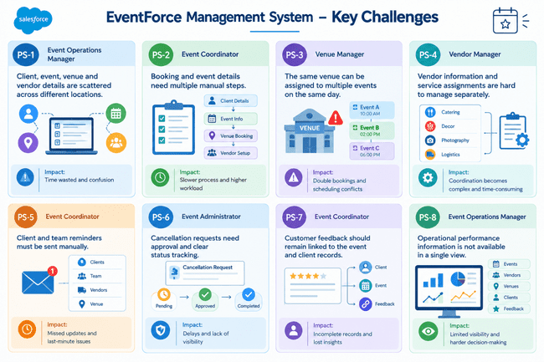

2.2 Empathy Map Canvas
User Persona: Event Coordinator
Role: Event Coordinator
Primary Responsibility: Manage bookings, venues, vendors, reminders, and event status
- Think & Feel: Wants smooth events with fewer errors and conflicts.
- Hear: Client requirements, vendor updates, and admin instructions.
- See: Event details, venue availability, vendor assignments, and event status.
- Say & Do: Coordinates stakeholders, updates records, and tracks event progress.
- Pain: Manual work, scattered information, booking conflicts, and multiple tasks.
- Gain: Centralized platform, automation, accurate availability, better coordination, and clear reports.

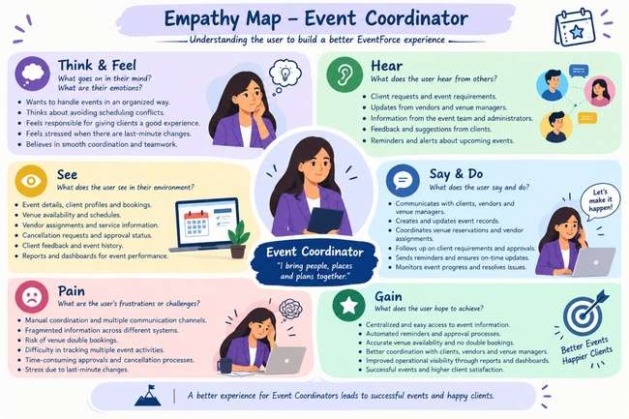

2.3 Brainstorming & Idea Prioritization
Ideas Considered
Idea | Approach | Key Limitation
Manual  Registers | Record event, client, venue, and vendor information manually | Requires significant time and is difficult to maintain
Spreadsheet  Tracking | Maintain bookings and event details using spreadsheets | Provides limited automation and coordination
Standalone  Portal | Build a separate application specifically for event management | Requires greater development and maintenance effort
Salesforce CRM | Manage event operations through a centralized Salesforce application | Requires suitable Salesforce configuration and implementation

Final Selection
Salesforce CRM was chosen for the EventForce Management System because of the following key advantages:
- Automation: Simplifies reminders, approval workflows, status changes, and routine business activities.
- Scalability: Can accommodate the growth of events, users, records, and changing business needs.
- Real-Time Visibility: Keeps information centralized and provides reports and dashboards for effective monitoring.
Decision: Salesforce CRM is well suited for developing a centralized, automated, scalable, and efficient EventForce Management System.
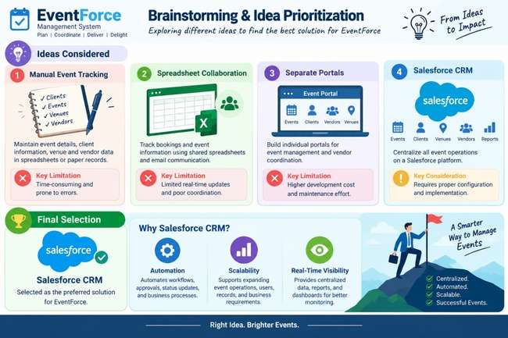

3.REQUIREMENT ANALYSIS PHASE
3.1 Customer Journey Map

Stage | Customer Journey Stage | Activities
1 | Event Enquiry & Client  Registration | Client requirements and contact information are entered into Salesforce.
2 | Event Planning & Booking | Event type, date, budget, status, and other planning information are created and maintained.
3 | Venue Selection & Reservation | Appropriate venues are identified, availability is verified, and reservations are recorded while avoiding duplicate bookings.
4 | Vendor Coordination | Required vendors and services are connected to events, and their availability is monitored.
5 | Event Confirmation &  Communication | Once an event is confirmed, automated communication and reminders are provided to clients.
6 | Event Execution & Monitoring | Event progress and operational details are tracked using Salesforce records, reports, and dashboards.
7 | Cancellation & Approval | Cancellation requests are submitted for approval, followed by suitable status changes and notifications.
8 | Feedback & Closure | Client feedback is recorded after the event and completed events are maintained for future analysis.

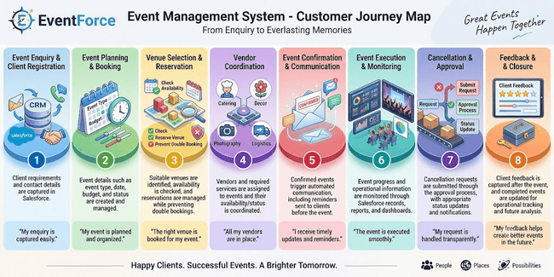

3.2 Solution Requirements
Functional Requirements
FR No | Requirement
FR-1 | Manage events
FR-2 | Maintain client information
FR-3 | Manage venues
FR-4 | Maintain vendor information
FR-5 | Assign vendors to events
FR-6 | Track venue availability and avoid double bookings
FR-7 | Generate automatic event reminders
FR-8 | Process event cancellation approvals
FR-9 | Record and manage feedback
FR-10 | Generate reports and dashboards
FR-11 | Automate event status changes
FR-12 | mport data through Data Import Wizard

Non-Functional Requirements

NFR | Description
Usability | Provides a Lightning App that makes event management and navigation easier.
Security | Uses profiles, roles, permission sets, and related security controls to restrict access.
Reliability | Maintains accurate automation, approval processes, and venue booking validation.
Performance | Processes event and operational information efficiently.
Availability | Processes event and operational information efficiently.
Scalability | Can accommodate an increasing number of events, clients, vendors, venues, and users.
Maintainability | Flows, Apex components, validation rules, and security settings can be maintained and modified when required.
Data Integrity | Uses validation and controlled data migration techniques to maintain reliable records.

3.2 Data Flow Diagram

Flow:

Client / Event Team
↓
Enter Client and Event Information
↓
EventForce Salesforce System
↓
Validate and Store Information
↓
Event, Client, Venue & Vendor Records
↓
Verify Venue Availability
↓
Allocate Venue and Vendors
↓
Confirm Event
↓
Send Automated 3-Day Reminder
↓
Execute Event and Update Status
↓
Collect Feedback
↓
Generate Reports and Dashboards

Supporting Processes
Cancellation Request
Event Coordinator
↓
Cancellation Request
↓
Approval Process
↓
Approved / Rejected
↓
Event Status Update
↓
Notifications

Venue Booking Validation
Event
↓
Apex Trigger
↓
VenueStatusHelper
↓
Check Existing Venue and Event Date
↓
Prevent Duplicate Booking / Update Venue Availability

Event Completion
Event Date Passed
↓
Scheduled Apex
↓
Batch Apex
↓
Event Status = Completed

Simplified System Representation
Clients / Event Coordinators / Vendor Managers / Venue Managers
↓
Salesforce CRM – EventForce
↓
Custom Objects: Event | Client | Vendor | Venue | Feedback | EventVendor
↓
Automation & Business Logic: Flows | Approval Process | Apex
↓
Operational Data & Status Updates
↓
Reports & Dashboards
↓
Event Operations and Decision-Making

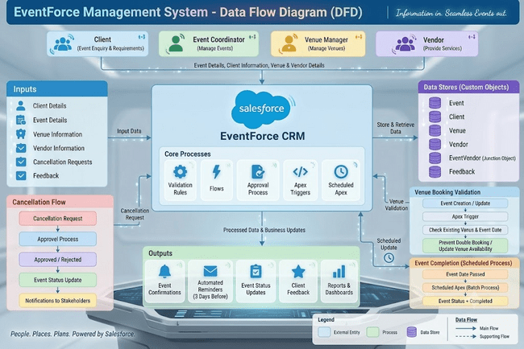

3.4 Technology Stack

Layer | Technology
Platform | Salesforce CRM / Developer Edition
UI | Salesforce Lightning App
Database | Salesforce Custom Objects
Business Logic | Salesforce Flows, Formula Fields, Validation Rules
Approval | Salesforce Approval Process
Automation | Record-Triggered Flows, Apex Triggers
Processing | Batch Apex, Scheduled Apex
Security | Profiles, Roles, Permission Sets, Sharing Rules, OWD
Reporting | Salesforce Reports & Dashboards

4. PROJECT DESIGN PHASE
4.1 Problem–Solution Fit
The EventForce Management System connects the identified event-management challenges with Salesforce capabilities. By combining custom objects, automation, Apex programming, approval workflows, security configurations, and reporting tools, the application addresses important operational requirements.

Problem | EventForce Salesforce Solution | Benefit
Client, event, venue, and vendor information is spread across different places | Custom objects for Event, Client, Venue, Vendor, Feedback, and EventVendor | Creates a centralized and organized data structure
Event booking involves many manual activities | Event booking involves many manual activities | Minimizes repetitive work and improves efficiency
Venues may be booked more than once | Apex Trigger and VenueStatusHelper | Checks booking conflicts and prevents duplicate reservations
Vendor coordination is difficult to monitor | EventVendor junction object and Vendor records | EventVendor junction object and Vendor records
Clients may miss important event reminders | 3-Day Reminder Flow | Clients may miss important event reminders
Cancellation requests need controlled handling | Event_Cancellation_Process Approval Process | Provides a formal approval workflow and status control
Feedback needs to be associated with clients and events | Feedback needs to be associated with clients and events | Keeps feedback information organized
Keeps feedback information organized | Reports and EventForce Operations Dashboard | Provides centralized operational visibility

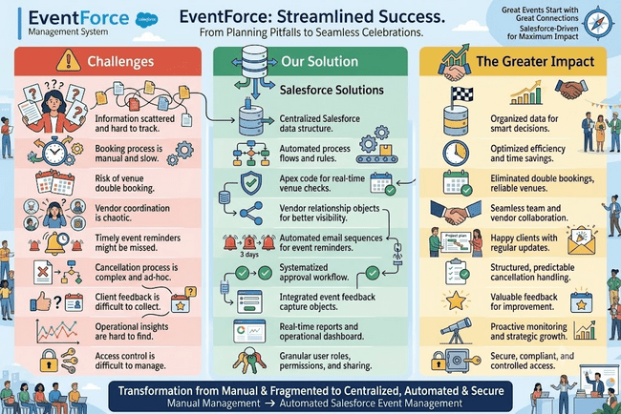

  - Proposed Solution
Functional Requirements
Parameter | Description
Problem | Event management is manual and information is distributed across different areas
Solution | Salesforce CRM
Innovation | Automated reminders, venue conflict validation, and cancellation approval workflows
Impact | Quicker event coordination and improved visibility into operations
Business Model | Centralized event planning and management
Scalability | Capable of supporting increasing numbers of events, clients, vendors, venues, and users

  - Solution Architecture
Components:
- Event Object
- Client Object
- Vendor Object
- Venue Object
- EventVendor Junction Object
- Feedback Object
- Rules
- Formula Fields
- Flows
- Approval Process
- Apex Triggers
- Apex Classes
- Batch Apex
- Scheduled Apex
- Profiles & Roles
- Permission Sets & Sharing Rules
- Data Import Wizard
- Lightning App
- Reports
- Dashboards
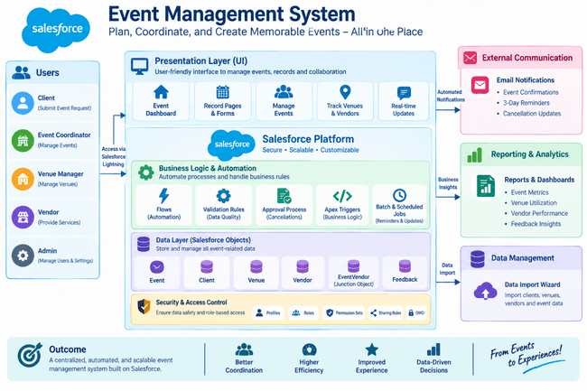

5. PROJECT PLANNING & SCHEDULING
5.1 Project Planning
The project follows an Agile development approach. Work is organized into manageable sprints to support incremental development and testing.
The planning approach includes:
- Defining Epics and User Stories.
- Assigning Story Points to individual tasks.
- Organizing development into sprints.
- Estimating work based on team capacity.
- Using velocity to measure sprint progress.
- Reviewing completed work at the end of each sprint.
Sprint | Functional  Requirement  (Epic) | User  Story | User Story / Task | Story Points | Priority | Team  Member
Sprint-1 | Event  Management | US-01 | As an Event Coordinator, I want to create events with type, date, and status so that event information remains standardized. | 3 | High | Member1
Sprint-1 | Client & Venue  Management | US-02 | As an Event Coordinator, I want to connect a client and venue to an event so that all coordination details are maintained together. | 5 | High | Member2
Sprint-2 | Vendor  Management | US-03 | As a Vendor Manager, I want to assign multiple vendors to an event so that services can be coordinated. | 5 | High | Member3
Sprint-2 | Notifications & Automation | US-04 | As a Client, I want to receive event reminders on time so that I am aware of my upcoming event. . | 3 | High | Member4
Sprint-3 | Approval  Management | US-05 | As an Event Coordinator, I want cancellation requests to pass through an approval workflow so that cancellations are properly controlled. | 5 | High | Member1
Sprint-3 | Venue  Management & Apex | US-06 | As a Venue Manager, I want the system to stop duplicate bookings so that venue schedules remain accurate. | 8 | High | Member2
Sprint-4 | Security &  Access Control | US-07 | As an Event Administrator, I want role-based access so that users can access only the information appropriate to their responsibilities. | 5 | Medium | Member3
Sprint-4 | Reports & Dashboards | US-08 | As Management, I want reports and dashboards so that event operations can be reviewed effectively. | 5 | Medium | Member4

Sprint | Total Story Points | Duration | Sprint Start Date | Sprint End Date (Planned) | Story Points  Completed  (as on  Planned End  Date) | Sprint Release Date (Actual)
Sprint-1 | 20 | 6 Days | 24 Oct 2022 | 29 Oct 2022 | 20 | 29 Oct 2022
Sprint-2 | 20 | 6 Days | 31 Oct 2022 | 05 Nov 2022
Sprint-3 | 20 | 6 Days | 07 Nov 2022 | 12 Nov 2022
Sprint-4 | 20 | 6 Days | 14 Nov 2022 | 19 Nov 2022

6. Project Development Phase:

Phase 1: Requirement Analysis & Planning
The EventForce Management System is developed on Salesforce to assist event management teams in handling client bookings, vendor coordination, venue reservations, and feedback activities through a single CRM platform.
The application automates important operations such as event scheduling, cancellation processing, client reminders, and event status management. Reports and dashboards provide centralized visibility into ongoing and completed event activities.

Functional Scope :
- Custom objects such as Event, Client, Vendor, Venue, Feedback, and Event Vendor.
- Relationship configuration using Lookup, Master-Detail, and Many-to-Many relationships.
- Salesforce Flows for reminders, feedback-related notifications, and automated process updates.
- Validation Rules and Formula Fields for maintaining accurate information and calculating event budgets.
- Approval Processes for handling event cancellation requests and sending appropriate notifications.
- Profiles, Roles, and Permission Sets for controlling access to application data.
- Reports and Dashboards for analyzing events, vendor performance, and upcoming activities.

Stakeholder Mapping :
- Clients: Submit event requirements, receive event-related updates, and provide feedback after the event.
- Event Coordinators: Handle event scheduling, client communication, bookings, and approval-related activities.
- Vendors: Provide services such as catering, decoration, photography, logistics, and other event requirements.
- Venue Managers: Monitor venue availability and manage venue reservations.
- Event Administrators: Supervise the overall Salesforce application, security configuration, and data management.

Execution Roadmap :
The development process is divided into the following activities:
- Object and Field Configuration – Create the Event, Client, Vendor, Venue, Feedback, and Event Vendor objects.
- Automation Flows – Configure record-triggered and scheduled automation for reminders and other business processes.
- Validation Rules and Formula Fields – Establish rules for data correctness and automated budget calculations.
- Profiles, Roles, and Permission Sets – Define user permissions and record-level visibility.
- Approval Process – Configure the cancellation request and approval workflow.
- Apex Classes and Triggers – Implement advanced venue availability and booking-conflict logic.
- Reports and Dashboards – Develop analytical views for event monitoring and performance tracking.
Phase 2 : Backend Development & Configurations

The Backend Development and Configuration phase establishes the main functional foundation of the EventForce Management System. Salesforce declarative features such as Record-Triggered Flows, Validation Rules, Formula Fields, and Approval Processes are used to automate activities including event confirmation, client reminders, and cancellation processing. For more advanced requirements, Apex Classes and Apex Triggers are implemented to manage venue availability and identify duplicate venue bookings. Security configurations including Profiles, Roles, Permission Sets, Sharing Rules, and OWD are used to control access to records and maintain information security. This phase converts the basic Salesforce structure into an automated and secure event-management solution capable of supporting practical event planning activities
Milestone 1 : Salesforce Account
What Is Salesforce ?
Salesforce is a cloud-based CRM platform that helps organizations manage customer relationships, business operations, sales, service, marketing, analytics, and collaboration. It provides tools for storing organizational information securely in the cloud and allows authorized users to access business data from different locations. For this project, Salesforce Developer Edition is used as the platform for creating and testing the EventForce Management System.

Activity 1: Creating Developer Account
A Salesforce Developer Org is created to develop and configure the EventForce application.
Procedure
- Open the Salesforce Developer signup page.
- Enter the required registration information:
  - First Name
  - Last Name
  - Email
  - Role – Developer
  - Company – College Name
  - Country – India
  - Postal Code – PIN Code
- Create a suitable username using your name and organization.
- The username does not necessarily need to be an actual email address. It can follow a format such as username@organization.com.
- Select Sign Me Up after entering all the required information

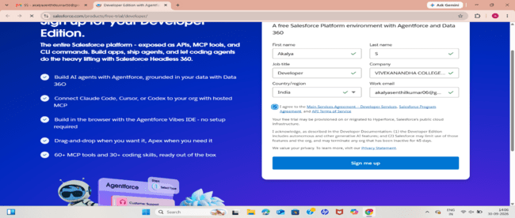
Activity 2: Account Activation
After completing the registration process:
1. Open the email account used during Salesforce registration.
2. Locate the Salesforce verification email.
3. Select Verify Account.
4. Enter a password when prompted.
5. Select and answer the security question.
6. Click Change Password.
7. After successful activation, Salesforce redirects the user to the Salesforce environment.

Data Architecture :
Created Custom objects:
The EventForce application contains the following custom objects:
- Event__c
(Fields: Event Name, Event Date, Event Type, Event Status, Event Budget)
- Client__c
(Fields: Client Name, Email, Phone, Address, Country, City)
- Vendor__c
(Fields: Vendor Name, Email, Phone, Service Type, Status)
- Venue__c
(Fields: Venue Name, Address, Location (URL), Capacity, Availability Status)
- Feedback__c
(Fields: Feedback ID (Auto Number), Rating, Comments)
- EventVendor__c (Junction Object)
(Links Event ↔ Vendor for Many-to-Many relationship)

Relationships:

Relationship | Type
Event → Client | Lookup
Event → Venue | Lookup
Feedback → Event | Lookup
Feedback → Client | Lookup
EventVendor → Event | Master-Detail
EventVendor → Vendor | Master-Detail

Steps to Implement :

Milestone 2- Object:

What is an object?
Salesforce objects function similarly to tables in a relational database. They are used to store information relevant to an organization. An object contains fields, which represent columns, and records, which represent individual rows of information.
The EventForce application uses the following custom objects:
- Event
- Client
- Vendor
- Venue
- Feedback
- Event Vendor

Activity 1: Create Event Object
Follow these steps to configure the Event custom object:
- Open Setup.
- Navigate to Object Manager.
- Select Create and choose Custom Object.
- Enter Event as the Label.
- Enter Events as the Plural Label.
- Set the Record Name to Event Name.
- Select Text as the data typ
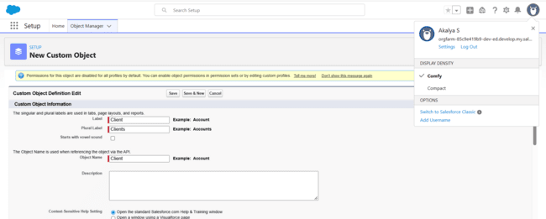

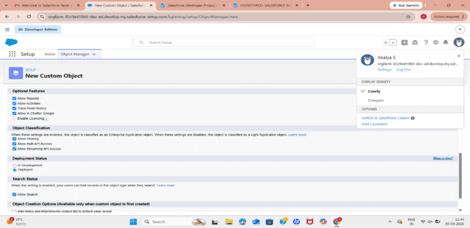
8. Under Optional Features, enable:
  - Allow Reports
  - Allow Activities
  - Track Field History
9. Under Deployment Status, select Deployed.
10. Under Search Status, enable Allow Search.
11. Under Object Creation Options, select Add Notes and Attachments related list to default page layout.
12. Keep the remaining settings unchanged.
13. Click Save.

Activity 2: Create Client Object

1. Select the Gear icon and open Setup.
2. Navigate to Object Manager.
3. Select Create → Custom Object.
4. Configure the object with the following values:
- Label: Client
- Plural Label: Clients
- Record Name: Client Name
- Data Type: Text
5. Enable Allow Reports.
6. Enable Allow Search.
7. Select Add Notes and Attachments related list to default page layout.
8. Click Save.

Activity 3: Create Vendor Object

1. Open Setup → Object Manager.
2. Select Create → Custom Object.
3. Enter the following details:
- Label: Vendor
- Plural Label: Vendors
- Record Name: Vendor Name
- Data Type: Text
4. Enable Allow Reports.
5. Enable Allow Search.
6. Enable Add Notes and Attachments related list to default page layout.
7. Click Save.

Activity 4: Create Venue Object

1. Open Setup → Object Manager.
2. Choose Create → Custom Object.
3. Enter:
- Label: Venue
- Plural Label: Venues
- Record Name: Venue Name
- Data Type: Text
4. Enable Allow Reports.
5. Enable Allow Search.
6. Select Add Notes and Attachments related list to default page layout.
7. Save the object.

Activity 5: Create Feedback Object

1. Navigate to Setup → Object Manager.
2. Select Create → Custom Object.
3. Configure the object as follows:
- Label: Feedback
- Plural Label: Feedbacks
- Record Name: Feedback
- Data Type: Auto Number
4. Enter the display format as F-{0000}.
5. Set the starting number to 0.
6. Enable Allow Reports.
7. Enable Allow Search.
8. Select Add Notes and Attachments related list to default page layout.
9. Click Save.

Milestone 3 - Tabs Tab:

Salesforce tabs provide users with an easy way to access and view records belonging to different objects. They serve as navigation points within the Salesforce application.

Standard Object Tabs:
Standard tabs provide access to Salesforce's predefined standard objects

Custom Object Tabs:
Custom tabs are created for custom objects and provide a similar navigation experience to standard Salesforce tabs.

Activity 1: Creating the Event Tab

Now create a custom tab.
1.Open the Home tab.

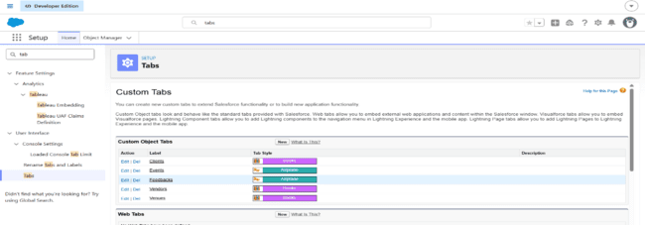
2. Search for Tabs using Quick Find.
3. Select Tabs.
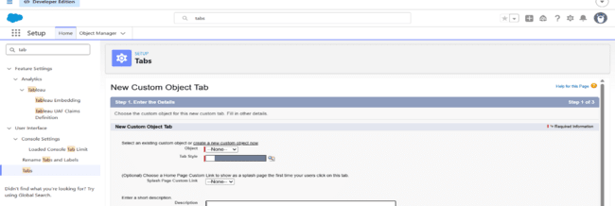
4. Under Custom Object Tabs, click New.
5. Select Event as the Object.
6. Choose a suitable Tab Style.
7. Click Next.
8. Set the required tab visibility and profile permissions.
9. Click Next and then Save.

Activity 2: Creating the Client Tab
1. Open Setup → Tabs.
2. Under Custom Object Tabs, click New.
3. Select Client as the Object.
4. Choose a suitable Tab Style.
5. Click Next, Next, and Save.

Activity 3: Creating the Vendor Tab
1. Navigate to Setup → Tabs.
2. Click New under Custom Object Tabs.
3. Select Vendor.
4. Choose a Tab Style.
5. Click Next, Next, and Save.

Activity 4: Creating the Venue Tab

- Open Setup → Tabs.
- Select New under Custom Object Tabs.
- Choose Venue.
- Select a suitable Tab Style.
- Click Next, Next, and Save.

Activity 5: Creating the Feedback Tab

- Go to Setup → Tabs.
- Select New under Custom Object Tabs.
- Select Feedback as the Object.
- Choose a Tab Style.
- Click Next, Next, and Save.

Milestone 4 – Fields and Relationship:

What are fields ?

Fields are used to store individual pieces of information within Salesforce records. Similar to columns in a relational database, fields define the type of information that can be stored for an object.
Salesforce fields can broadly be categorized as:

Standard Fields
Standard fields are automatically available with Salesforce objects. Examples include:
- Created By
- Last Modified By
- Owner
- Record Name
These system-defined fields generally cannot be removed or modified like custom fields.

Custom Fields
Custom fields are created by administrators or developers according to the requirements of the organization. Depending on the business requirement, these fields may be mandatory or optional.

Activity 1: Creating Fields for Event

Event Type
1. Open Setup → Object Manager → Event.
2. Select Fields & Relationships.
3. Click New.

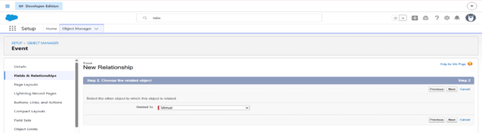
4. Select Picklist as the Data Type.
5. Enter Event Type as the Field Label.

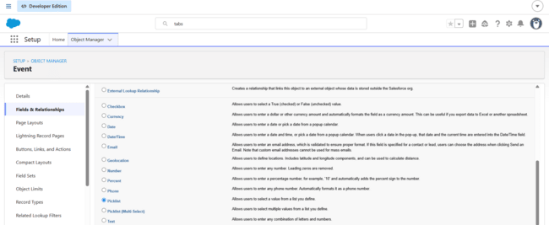
6. Select Enter values, with each value separated by a new line.
7. Add:
  - Wedding
  - Corporate
  - Birthday
  - Anniversary
  - Festival
  - Concert
  - Other

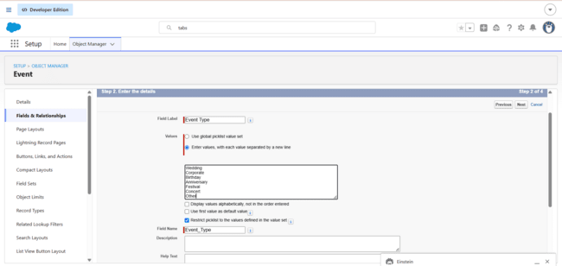

8. Click Next → Next → Save.
Event Date
- Create another field.
- Select Date as the Data Type.
- Enter Event Date as the Field Label.
- Click Next → Next → Save & New.

Creating the Event Budget Formula Field:

The Event Budget field automatically determines the expected budget based on the selected event type.
- Click New under Fields & Relationships.
- Select Formula as the Data Type.

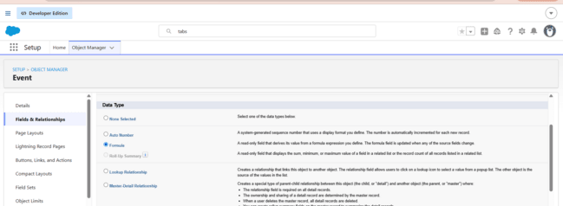

3. Enter Event Budget as the Field Label.
4. Select Currency as the Formula Return Type.

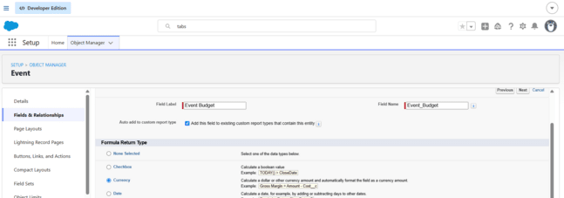

5. Enter the following formula:

CASE(
TEXT(Event_Type__c),
"Wedding", 50000,
"Corporate", 30000,
"Birthday", 10000,
"Anniversary", 20000,
"Festival", 60000,
"Concert", 40000,
"Other", 15000,
0
)
6. Use Check Syntax to verify the formula.

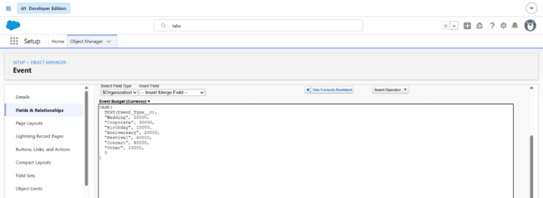

7. Click Next → Next → Save.

Activity 2: Creating Fields for Client

Email
- Select Email as the Data Type.
- Enter Email as the Field Label.
- Click Next → Next → Save & New.

Phone
- Select Phone as the Data Type.
- Enter Phone as the Field Label.
- Save the field.

Address
- Select Text Area.
- Enter Address as the Field Label.
- Save the field.

Country
- Select Picklist.
- Enter Country as the Field Label.
- Choose Enter values, with each value separated by a new line.
- Add:
- India
- Philippines
- Saudi Arabia
- USA
- Switzerland
- Thailand
- Maldives
- Dubai
- Sri Lanka
- Bangkok
- Singapore
- Myanmar
- France
- Nepal
- Save the field.

City

Create another Picklist field named City and enter:
- Hyderabad
- Mumbai
- Delhi
- Bangalore
- Chennai
- Alaminos
- Angeles City
- Palayan
- Quezon City
- San Juan
- Riyadh
- Jeddah
- Tayma
- Dammam
- Medina
- New York
- Los Angeles
- Chicago
- Houston
- Columbus
- Geneva
- Basel
- Lausanne
- Bern
- Lucerne
Save the field after entering the values.

Activity 3: Creating Fields for Vendor:

Service Type
- Select Multi-Select Picklist as the Data Type.
- Enter Service Type as the Field Label.
- Add:
- Catering
- Decor
- Photography
- Videography
- Lighting
- Stage Setup
- Makeup Artist
- DJ/Music
- Transportation
- Hosting/Anchor
4. Save the field.

Email
Create an Email field with the label Email.
Phone
Create a Phone field with the label Phone.
Status
Create a Picklist field named Status and add:
- Available
- Booked
- Cancelled
Save the field.

Activity 4: Creating Fields for Venue:

Address
Create a Text Area field named Address.
Location
Create a URL field named Location.
Capacity
Create a Number field named Capacity.
Availability Status
Create a Picklist field named Availability Status with:
- Available
- Reserved
- Not Available
Save the field.

Activity 5: Creating Fields for Feedback:

Rating
- Select Picklist.
- Set the Field Label to Rating.
- Add:
- 1
- 2
- 3
- 4
- 5
Comments
Create a Long Text Area field with the label Comments.
Save the field.
Relationships:
Relationships connect Salesforce objects so that related records can be associated with one another.

Activity 1: Lookup Relationship for Event:

Event → Venue
- Open Setup → Object Manager → Event.
- Select Fields & Relationships.
- Click New.
- Select Lookup Relationship.
- Click Next.

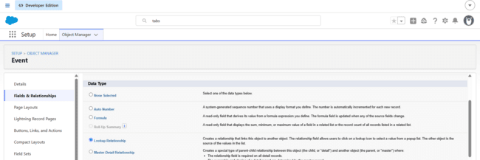

6. Select Venue as the Related Object. 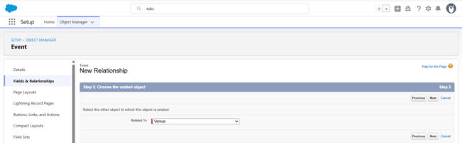
7. Enter Venue as the Field Label.
8. Continue through the remaining configuration screens.
9. Click Save.

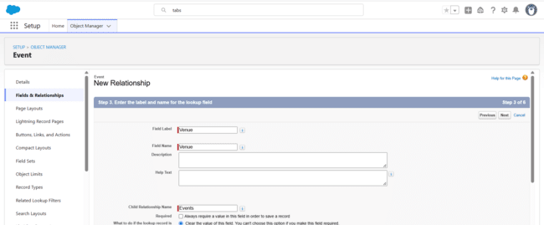

Creating the Many-to-Many Relationship:

Salesforce requires a junction object to establish a many-to-many relationship between two objects. For the EventForce application, EventVendor__c acts as the junction object between Event and Vendor.

Create Event Vendor Object
1. Open Object Manager.
2. Select Create → Custom Object.
3. Set the Label as Event Vendor.
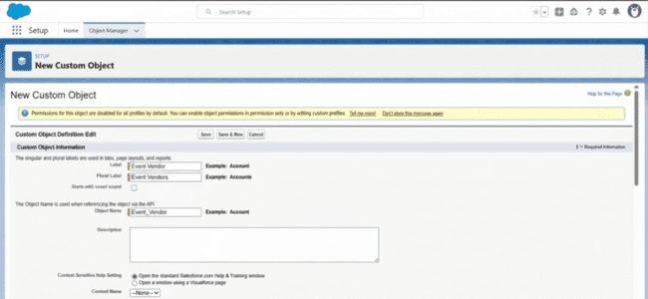

4. Set the Object Name as EventVendor__c.
5. Save the object.

EventVendor → Event

- Open the Event Vendor object.
- Select Fields & Relationships.
- Click New.
- Select Master-Detail Relationship.
- Choose Event as the Related Object.
- Enter Event as the Field Label.
- Complete the remaining steps and select Save & New.

EventVendor → Vendor

- Select Master-Detail Relationship.
- Choose Vendor as the Related Object.
- Enter Vendor as the Field Label.
- Complete the configuration.
- Click Save.
This creates the many-to-many connection: Event ↔ EventVendor ↔ Vendor

Activity 2: Relationships for Feedback:

Feedback → Event
- Open Feedback from Object Manager.
- Select Fields & Relationships.
- Click New.
- Select Lookup Relationship.
- Select Event as the Related Object.
- Set the Field Label to Event.
- Complete the configuration and save.

Feedback → Client
- Create another Lookup Relationship.
- Select Client as the Related Object.
- Set the Field Label to Client.
- Complete the remaining steps and save.

Activity 3: Lookup Filters

Scenario:
When a user creates a Feedback record, the Event lookup should display only the events associated with the selected Client.
For example, if the Client Ramesh is selected, the Event lookup should show only Ramesh's events.
Configuration
- Open Setup.
- Search for Object Manager in Quick Find.
- Open the Feedback object.
- Select Fields & Relationships.
- Locate the Event lookup field.
- Open the Event field.
- Click Edit.
- Locate the Lookup Filter section.
- Select Show Filter Settings.
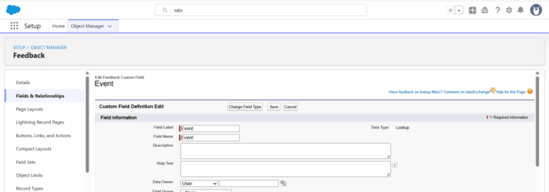
10. Configure the condition:
    - Field: Event → Client__c
    - Operator: equals
    - Value: Field → Feedback → Client__c
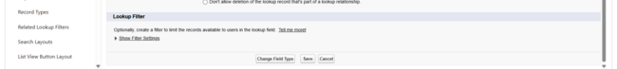

11. Enable the Enable this Filter option.
12. Click Save.Click on Save.
This ensures that the Event lookup is dynamically restricted according to the selected Client.

Milestone 5 -Validation Rules :

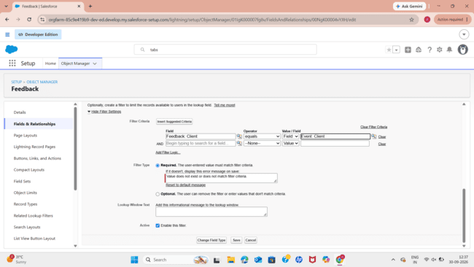

Validation Rules verify information before Salesforce allows a record to be saved. When the entered information fails the defined condition, Salesforce displays an error and prevents the record from being saved until the issue is corrected.

Activity 1: Validation Rule for Client:

Rule Name
Email_Valid_Address
Configuration
- Open Setup.
- Navigate to Object Manager.
- Search for and open Client.
- Select Validation Rules.
- Click New.
- Enter the Rule Name as Email_Valid_Address.
- Enable Active.
- Enter the following Error Condition Formula: NOT(REGEX(Email__c, "^[a-zA-Z0-9._]+@[a-zA-Z0-9.]+\\.[a-zA-Z]{2,}$" ))
- Enter the Error Message: Please Enter Valid Email Address
- Set Error Location to Field.
- Select the Email field.
- Click Save.
This rule ensures that the Client email follows the required email format.

Milestone 6 : APPROVAL PROCESS

Activity 1: Event Cancellation Approval

An approval process is used to control event cancellation requests. Before configuring the approval process, the required Profiles, Roles, and Users should be configured.

1. Create Classic Email Template
1. Open Setup.
2.Search for Email Templates in Quick Find.
3. Open Classic Email Templates.
4. Click New Template.

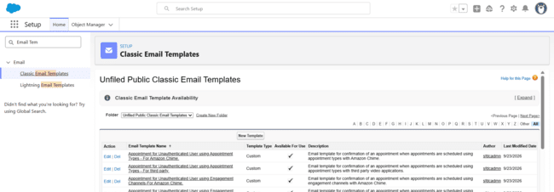

5. Select Text as the template type.
6. Click Next
7. Email Template Information:

Folder | Unfiled Public Email Templates
Email Template Name | Event Cancellation Request Notification
Template Unique Name | Automatically generated
Encoding | UTF-8
Subject | Approval Request: Cancel Event {!Event__c.Name}
Email Body | Hello!  An approval request has been submitted to cancel the event:  - Event Name: {!Event__c.Name}  - Event Date: {!Event__c.Event_Date__c}  Thank you,  EventForce Management System

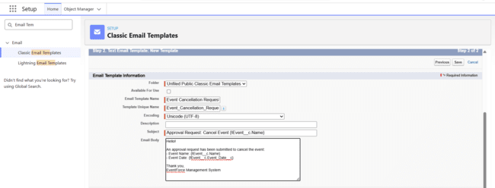

2. Client Cancellation Notification Template

Create another text email template.
Template Name: Email to Client After Cancellation
Subject: Event Cancellation Notice – {!Event__c.Name}
The message informs the client that the event has been cancelled and provides the event name and date.

3. Approved Cancellation Notification
Create an email template for the event owner.
Template Name: Approval Notification to Event Owner
Subject: Event Cancellation Approved: {!Event__c.Name}
The notification informs the event owner that the cancellation request was approved and that the event status has changed to Canceled.

4. Rejected Cancellation Notification
Create another template for rejected requests.
Template Name: Rejection Notification to Event Owner
Subject: Event Cancellation Rejected: {!Event__c.Name}
The message informs the event owner that the cancellation request was rejected and provides the relevant event information.

5. Configure the Approval Process
- Open Setup.
- Search for Approval Processes.
- Open Approval Processes under Process Automation.
- Select the Event object.
- Choose Create New Approval Process.
- Select Use Standard Setup Wizard.

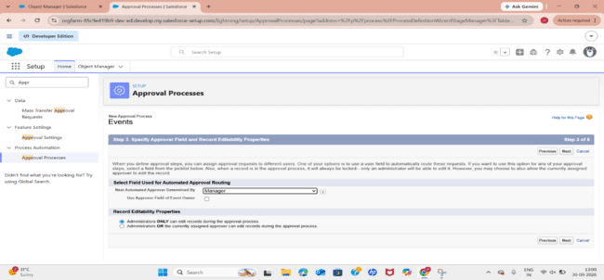

Step 1: Basic Settings
  - Name: Event_Cancellation_Process
  - Unique Name: Automatically generated.
  - Click Next.
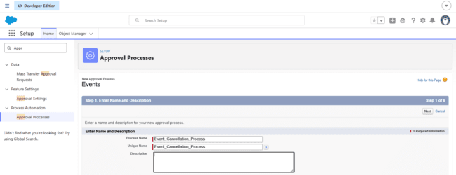

Entry Criteria
Select:
Criteria are met
Configure the condition:
- Field: Event → Event Status
- Operator: Equals
- Value: Pending Cancellation
Click Next.

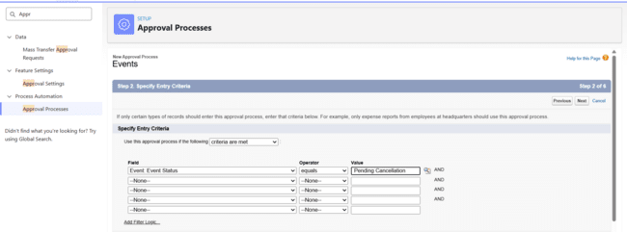

The approval can be assigned using either of the following methods.
Option 1: Specific User

Select:
- Automatically assign using user or queue
- Then choose the required manager or specific user.

Option 2: User's Manager
Select:
- Automatically assign to the manager of the user who submitted the record
- The relevant Salesforce users should have a Manager assigned in their User records.
- Click Next.

Step 2: Email Template
Approval Assignment Email Template:
- For the approval assignment notification, select:
- Event Cancellation Request Notification
- Click Next.

Step 3: Approval Page Layout Fields
Select the important Event fields that should be visible to the approver.
Recommended fields include:
- Event Name
- Owner
- Client
- Last Modified By
- Created By
- Event Budget
- Event Date
- Event Status
- Event Type
- Venue
- Move the required fields from the Available Fields section to Selected Fields.
- Use the arrow controls to arrange the fields in the desired order.
- Click Next.

Step 4: Specify Initial Submitters

Select: Event Owner as the Initial Submitter.
- Click Save.

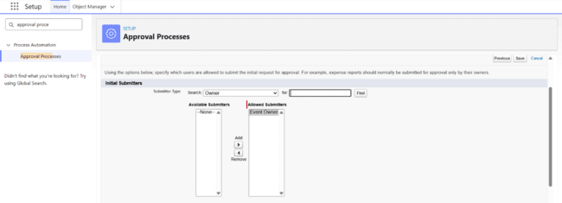

Step 5: Initial Submission Actions

After submission, configure an email notification.
- Click Add New.
- Select Email Alert.

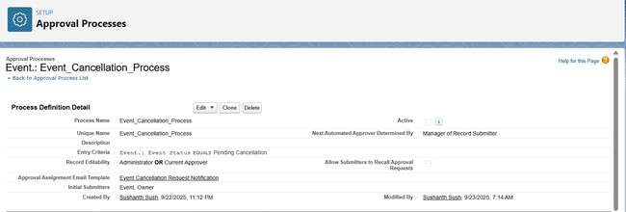

3. Enter:
- Description: Alert - Event Cancellation Request
- Unique Name: Automatically generated
- Object: Event__c
- Email Template: Event Cancellation Request Notification
- Recipient: Event Coordinator
- From Email Address: Current User's Email Address
4. Save the action.

Step 6: Final Approval Actions

Field Update
- Click Add New → Field Update.
2. Select Event Status as the field.
3. Set the name as Event Status Update.
4. Set the new value to: Canceled
5. Save.

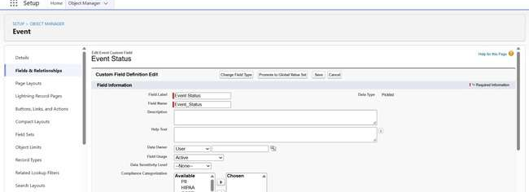

Email Alert
Create another Email Alert:
- Description: Alert - Cancellation Approved
- Email Template: Approval Notification to Event Owner
- Recipient: Event Owner
- From Email Address: Current User's Email
Save the action.
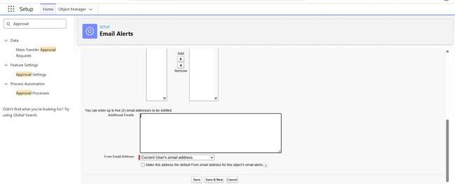
Step 8: Final Rejection Actions
Create an Email Alert:
- Description: Alert - Cancellation Rejected
- Email Template: Rejection Notification to Event Owner
- Recipient: Event Owner
- From Email Address: Current User's Email
Save the action.
Then configure a Field Update:
- Field: Event Status
- Name: Event Status To Rejected
- New Value: Rejected
Save the action.

Step 9: Approval Steps
- Click Add New Step.
- Enter the Step Name: Manager Review
- Allow Salesforce to generate the Unique Name.
- Click Next.
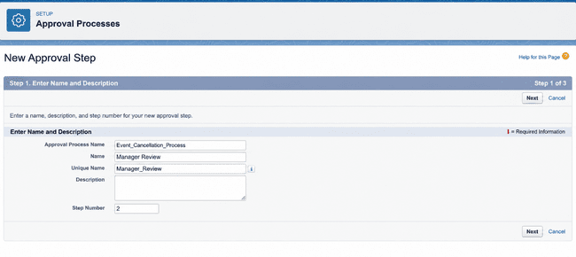

5. Select: All records should enter this step
6. Click Next.
7. Assigned Approver
- Select the appropriate automatic approver configuration, such as:
- Automatically assign to approver(s)
- Then specify the required user or related user.
- Click Save.
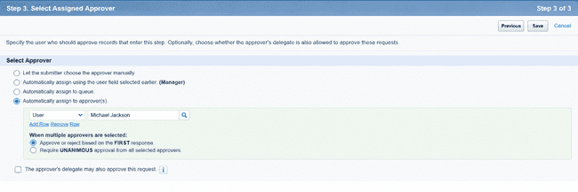
Step 10: Activate the Approval Process
- Open View Approval Process Detail Page.
- Review the complete configuration.
- Click Activate.
The Event Cancellation Approval Process is now available for use.

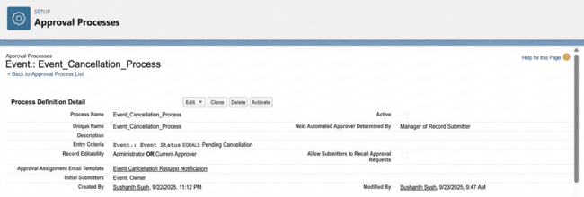

Milestone 7 - Flows

A Salesforce Flow is a visual automation tool used to automate business processes, update records, perform actions, and guide users through predefined steps.
Flows can automate many tasks without requiring traditional programming.

Activity 1 : 3-Day Event Reminder Flow
Scenario:
When an Event is created or updated with the status Confirmed, and a valid Client with an email address is associated with it, Salesforce should automatically send an email reminder three days before the Event Date.

Step 1: Create a Record-Triggered Flow
- Open Setup.
- Search for Flow using Quick Find.
- Select Flows.
- Click New Flow.

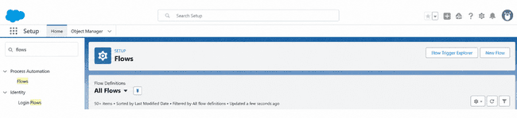

5. Select Record-Triggered Flow.
6. Click Create.

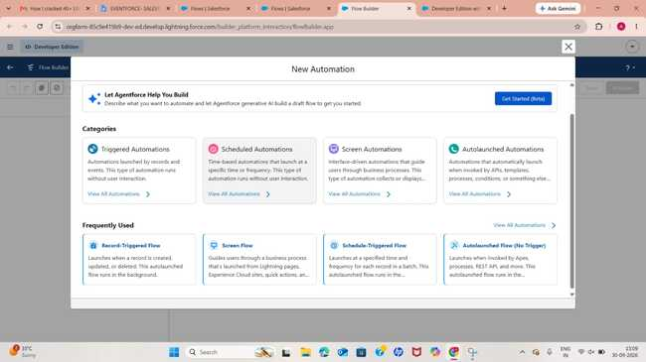

Step 2: Configure the Trigger
- Select the Event object.

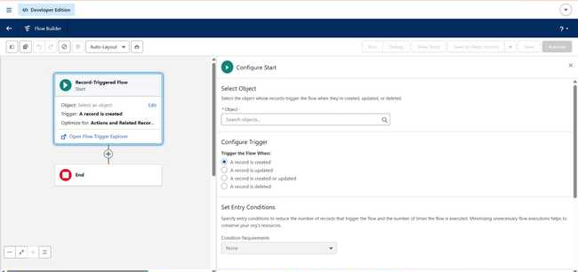

2. Choose: A record is created or updated
- Set the condition:
  - Field: Event Status
  - Operator: Equals
  - Value: Confirmed
- Under optimization, select: Actions and Related Records
- Click Done.

Step 3: Create the Scheduled Path
1. Select the Start element.
2.Click Add Schedule Path.

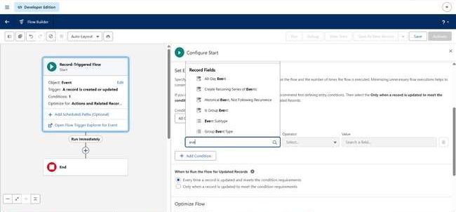

3. Enter Path Name: 3_Days_Before
4. The API Name is automatically populated.
5. Set the Time Source to: Event__c: Event Date
6. Enter Offset Number: 3
7. Select: Days Before.
8. Close the configuration window.

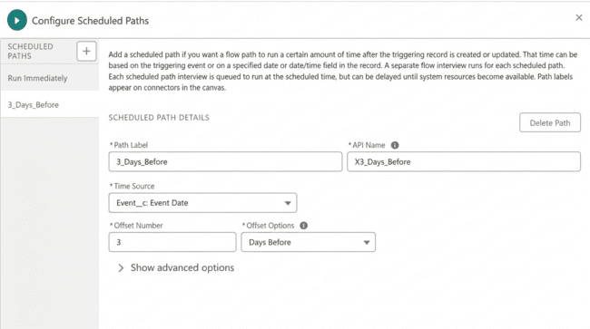

Create the Email Subject Resource
- Open the Toolbox.
- Select New Resource.
- Choose Text Template

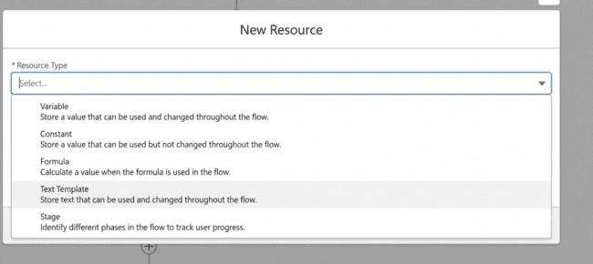

4. Enter API Name: Subject
- Enter: Reminder: Your Event {!$Record.Name} is in 3 days
- Select View as Plain Text.
- Click Done.
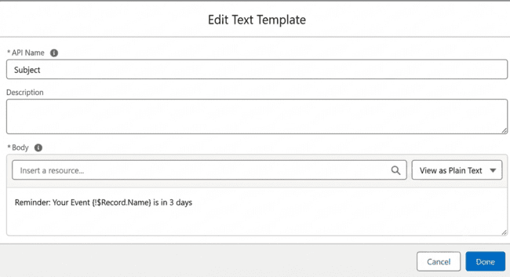

Create the Email Body Resource

Create another Text Template.
API Name: Body
Use the following message:
Hello {!$Record.Client__r.Name},

This is a reminder that your event "{{!$Record.Name}" will take place on {!$Record.Event_Date__c}.
Venue: {!$Record.Venue__r.Name}
Type: {!$Record.Event_Type__c}

We look forward to seeing you!

- EventForce Team
Select View as Plain Text and click Done.
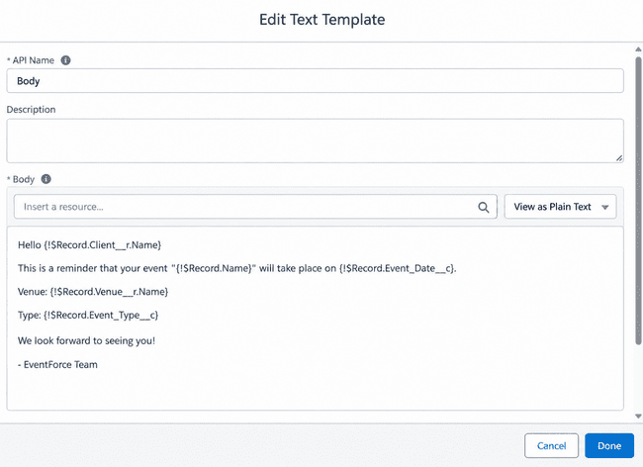

Add Send Email Action
- Under 3 Days Before, click the + symbol.
- Select Action.
- Search for Send Email.

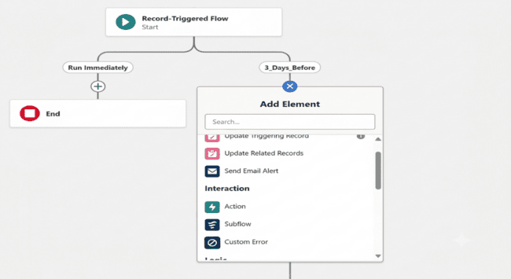

4. Select the Send Email action.
5. Enter the Label: Alert_Client_3Day_Reminder

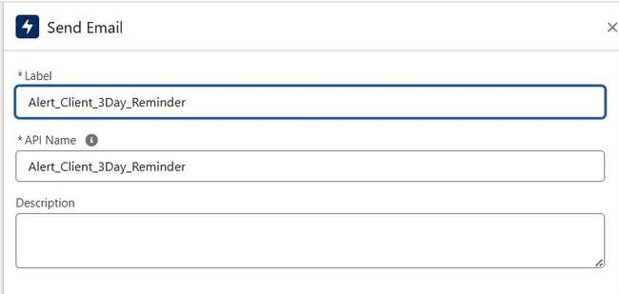

6. Set the Recipient Address List to the Client Email.
7. Set the CC Recipient Address List to the Event Owner.
8. Select Compose Email Content.
9. Set Subject to the Subject resource.
10. Set Body to the Body resource.
11.Save the action.
12.Set the Flow Label to: Client Reminder - 3 Days Before

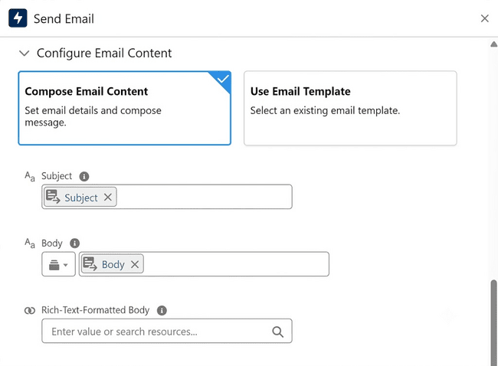
- Click Save.
- Click Activate.
The system can now send the reminder automatically before the confirmed event.

Milestone 8 – Apex Classes

Activity1:
Scenario:
When an Event is associated with a Venue and becomes Confirmed, the Venue's availability should be changed to Reserved.
When the Event is Canceled, the Venue should become Available again.

Create Apex Class:
1. Open the Gear icon.
2. Select Developer Console.
3. Select File → New → Apex Class.

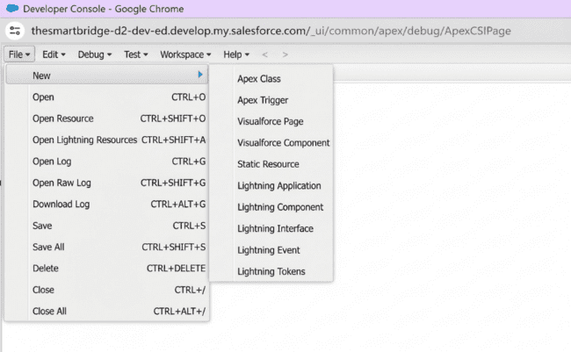

4. Enter the class name: VenueStatusHelper
5. Click OK.

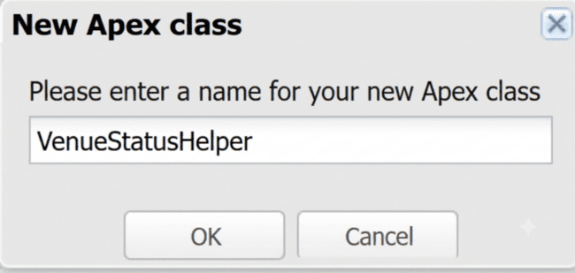

6.Write your Apex Class Code

Apex Class
public with sharing class VenueStatusHelper {
public static void updateVenueStatus(List<Event__c> events){
List<Venue__c> venues = new List<Venue__c>();

for(Event__c ev : events){
if(ev.Venue__c != null){
if(ev.Event_Status__c == 'Confirmed'){
venues.add(new Venue__c(
Id=ev.Venue__c,
Availability_Status__c='Reserved'
));
} else if(ev.Event_Status__c == 'Canceled'){
venues.add(new Venue__c(
Id=ev.Venue__c,
Availability_Status__c='Available'
));
}
}
}

if(!venues.isEmpty())
update venues;
}
}
7. Save the class using Ctrl + S.

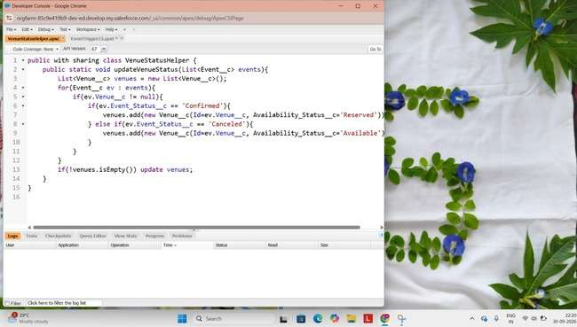

Create the Trigger :

1. Open Developer Console.
2. Select File → New → Apex Trigger.
3.Enter the Trigger Name: EventTrigger13
4.Select Event__c as the Object.
5. Click Submit.
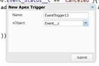
6. Write Apex trigger Code

Apex Trigger
trigger EventTrigger13 on Event__c (after insert, after update) {
VenueStatusHelper.updateVenueStatus(Trigger.new);
}
7. Save the trigger using Ctrl + S.
This trigger invokes the helper class whenever Event records are inserted or updated.

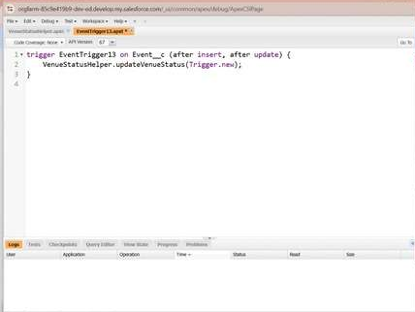

Milestone 9 – Apex Trigger

Activity1:
Scenario: The application should not allow two different Events to use the same Venue on the same Event Date.

Create an Apex Trigger:
1. Open Developer Console.
2. Select File → New → Apex Trigger.
3. Enter the Trigger Name: PreventDoubleBooking
4. Select Event__c as the Object.
5. Click Submit.
6. Write Apex trigger Code

Source Code :
trigger PreventDoubleBooking on Event__c (before insert, before update) {
Set<Id> venueIds = new Set<Id>();

for(Event__c ev : Trigger.new){
if(ev.Venue__c != null)
venueIds.add(ev.Venue__c);
}

Map<Id, List<Event__c>> venueEventMap =
new Map<Id, List<Event__c>>();

for(Event__c e : [
SELECT Id, Venue__c, Event_Date__c
FROM Event__c
WHERE Venue__c IN :venueIds
]){
if(!venueEventMap.containsKey(e.Venue__c)){
venueEventMap.put(
e.Venue__c,
new List<Event__c>()
);
}

venueEventMap.get(e.Venue__c).add(e);
}

for(Event__c ev : Trigger.new){
if(ev.Venue__c != null &&
venueEventMap.containsKey(ev.Venue__c)){

for(Event__c existing :
venueEventMap.get(ev.Venue__c)){

if(existing.Event_Date__c == ev.Event_Date__c &&
existing.Id != ev.Id){

ev.addError(
'This Venue is already booked on this date.'
);
}
}
}
}
}
7. Save the trigger using Ctrl + S.

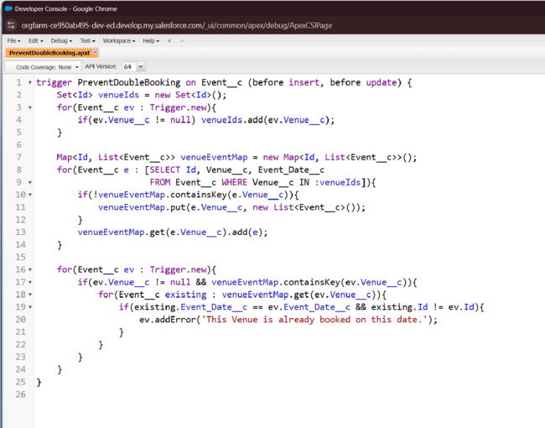

Milestone 10: Batchable and Schedulable Asynchronous Apex

Scenario: Past Events need to be automatically identified and their status should be changed to Completed. To perform this task efficiently, the application uses Batch Apex together with Scheduled Apex.

Step 1: Create Batch Apex Class:
- Open the Gear icon.
- Select Developer Console.
- Choose File → New → Apex Class.
- Enter: BatchCompleteEvents
- Click OK.

Batch Apex Code
global class BatchCompleteEvents implements Database.Batchable<sObject> {

global Database.QueryLocator start(Database.BatchableContext bc){
return Database.getQueryLocator(
'SELECT Id, Event_Date__c, Event_Status__c FROM Event__c WHERE Event_Date__c < TODAY AND Event_Status__c != \'Completed\''
);
}

global void execute(
Database.BatchableContext bc,
List<Event__c> scope
){
for(Event__c ev : scope){
ev.Event_Status__c = 'Completed';
}

update scope;
}

global void finish(Database.BatchableContext bc){
System.debug('Past events marked as Completed');
}
}
6. Save the class using Ctrl + S.

Step 2: Create the Schedulable Apex Class
1. Open Developer Console.
2. Select File → New → Apex Class.
3. Enter: ScheduleCompleteEvents
- Click OK.

Schedulable Apex Code
global class ScheduleCompleteEvents implements Schedulable {

global void execute(SchedulableContext sc){
Database.executeBatch(
new BatchCompleteEvents(),
200
);
}
}
- Save the class using Ctrl + S.

Step 3: Schedule the Batch Apex

1. Open Salesforce Setup.
2. Search for Apex Classes or Scheduled Jobs in Quick Find.
3. Select the scheduling option available in the Salesforce Developer Edition.

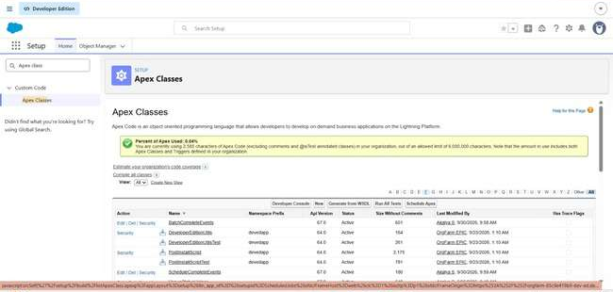

4 .Select the ScheduleCompleteEvents class.
5. Configure the required schedule.
6. Set the preferred execution time.
7. Save the schedule.

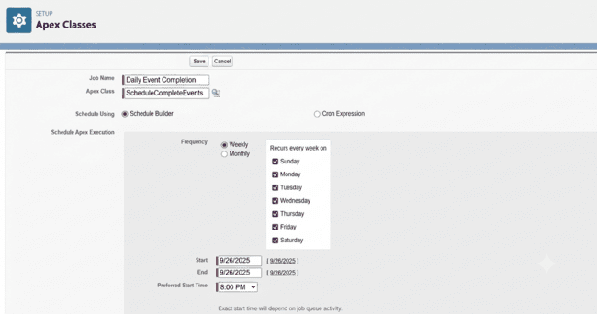

Once scheduled, Salesforce automatically executes the scheduled class according to the configured timing. The scheduled class then starts the batch process, which identifies past events and changes their status to Completed
Phase 3: UI/UX Development & Customization
The UI/UX Development and Customization phase is aimed at designing an easy-to-use and organized interface for the EventForce Management System. A customized Lightning App was created in Salesforce to bring important modules such as Events, Clients, Vendors, Venues, and Feedback together in one workspace. Reports and dashboards were also configured to provide visual insights into event schedules, vendor activities, and client feedback. The Upcoming Events by Month report supports event analysis, while the EventForce Operations Dashboard presents important operational information in a visual format. This phase provides users with a responsive, organized, and data-oriented interface for efficiently managing event activities through Salesforce Lightning.
Milestone 11 - The Lightning App:
What is an App ?
A Salesforce App is a collection of related tabs grouped together to provide users with access to specific application functions. Each app can have its own name, logo, and navigation items.
Activity 1: Creating a Lightning App
Create an application named Event Planner Management System
1. Open Setup and search for App Manager in the Quick Find box.
2. Select App Manager.
3. Click New Lightning App.
4. Enter Event Planner as the App Name.
5. Upload an appropriate image for the application.
6. Click Next. 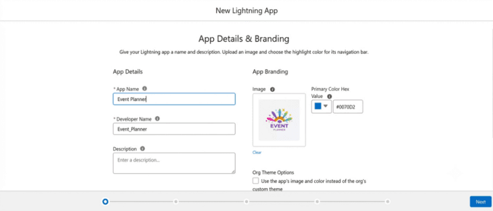
7. In App Options, retain the default settings and select Next.
8. In Utility Items, keep the existing configuration and click Next.
9. From Available Items, select:
- Event
- Client
- Vendor
- Venue
- Feedback
- Reports
- Dashboards
10. Move the selected items to Selected Items.
11. Click Next.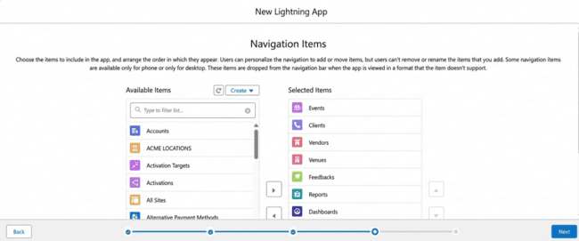
12. Under Available Profiles, select System Administrator.
13. Move it to Selected Profiles.
14. Click Save & Finish.

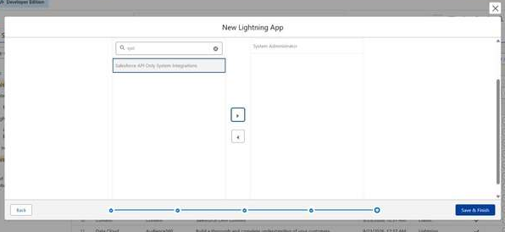

Verification
Open the App Launcher, search for Event Planner, and select the application to confirm that it has been created successfully.
Important Interface Components
- App Launcher: Provides access to available Salesforce applications.
- App Name: Shows the application that is currently open.
- Navigation Menu: Displays the tabs included within the selected application.

Milestone 12 : Reports
Activity 1: Create a Report folder

- Open the App Launcher and search for Reports.
- Open the Reports tab.
- Click New Folder.
- Enter EventForce Report as the folder label.
- Salesforce automatically generates the folder's unique name.
- Click Save.

Activity 2: Sharing a Report folder

1. Open the Event Planner application.
2. Navigate to the Reports tab.
3. Open All Folders.
4. Locate the EventForce Report folder.
5. Click the drop-down arrow beside the folder.
6. Select Share.
7. Choose Roles as the sharing option.
8. Search for and select:
    - Event Coordinator
    - Vendor Manager
9. Provide View access to the selected roles.
10. Click Share and then select Done.

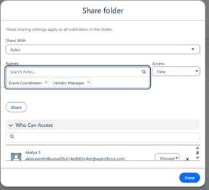

Activity 3: Create Report
Prerequisite
Before preparing reports, create at least 10 records for each object. Filling all available fields in the records provides better data for testing and analysis.

Report 1 : Upcoming Events — Summary by Month Use: Procedure
- Open the App Launcher.
- Select the Reports tab.
- Click New Report.
- Under Category, select All.
- Search for Events or Events with Client & Venue.
- Select the required report type.
- Click Start Report.
Configure Columns
Add the following fields:
- Event Name
- Event Date
- Event Type
- Client Name
- Venue Name
- Event Budget
Remove fields that are not required.
Enable Update Preview Automatically.
Configure Filters
Under Filters, set:
- Show Me: All Events
- Event Date: Greater than or equal to TODAY or Next 30 Days
- Event Status: Not equal to Canceled

Group the Records
Under Group Rows:
- Select Event Date.
- Open the date grouping option.
- Choose Group by Calendar Month.

Add Summary Information
Select Add Summary and configure:
- Row Count
- Event Budget → SUM
This allows the report to display the total number of events and the combined event budget for each month.

Add a Chart
- Click Add Chart.
- Choose either Column or Line chart.
- Set the X-axis to Event Date – Calendar Month.
- Set the Y-axis to either:
  - Row Count, or
  - SUM(Event Budget)

Save the Report
- Click Save.
- Enter the report name as Upcoming Events by Month.
- Allow Salesforce to generate the Report Unique Name.
- Select the EventForce Reports folder.
- Click Save.
- Select Run to view the report.
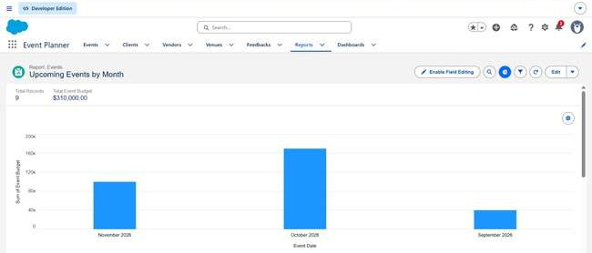

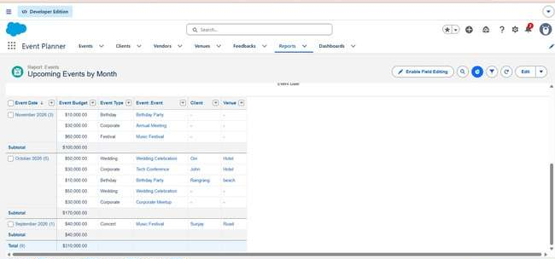

Milestone 13 - Dashboards

Activity 1: - Create Dashboard

Create EventForce Dashboard
Create a dashboard named EventForce Operations Dashboard.
- Open the Dashboards tab from the EventForce Management System application.
- Click New Dashboard.
- Enter EventForce Operations Dashboard as the dashboard name.
- Click Create.
- Select + Widget.
- Choose the Upcoming Events by Month report.
- Configure the widget:
  - Chart Type: Donut Chart
  - Maximum Values Displayed: 6
  - Subtitle: Upcoming Events Overview
  - Widget Theme: Light
- Click Save.
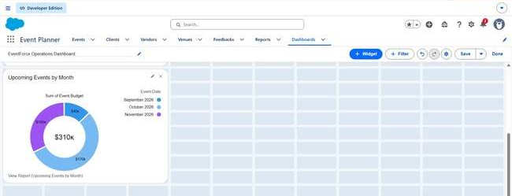

The dashboard now provides a visual representation of upcoming event information.

Phase 4 : Data Migration, Testing & Security
This phase prepares the EventForce system for reliable and secure operation. It involves importing validated information, creating user accounts, configuring access permissions, and testing the system. Records belonging to Events, Clients, Vendors, Venues, and Feedback are imported into Salesforce using the Data Import Wizard. Before importing, the information is checked to reduce duplicate records and maintain data consistency. Separate user accounts are created for Event Admin, Event Coordinator, Vendor Manager, and Client. Each user is assigned suitable profiles and roles according to their responsibilities. Security is implemented using Profiles, Role Hierarchy, Permission Sets, and Sharing Rules. The Organization-Wide Defaults (OWD) are configured as Private so that record access can be granted selectively through appropriate sharing rules such as Event_Sharing_For_Vendors. Testing is performed to verify data accuracy, automation behavior, and user access. As a result, the system is prepared to operate as a secure, dependable, and functional event-management platform.

Milestone 14- Profile:
What is a profile?
A Salesforce Profile is a collection of permissions and settings that determines the actions a user can perform within Salesforce.
A profile can control:
- Object permissions
- Field-level permissions
- User permissions
- Tab visibility
- App access
- Apex class access
- Visualforce page access
- Page layouts
- Record types
- Login hours
- Login IP ranges
A single profile can be assigned to multiple users, while each individual user can have only one profile at a time.

Activity 1:
Create a custom profile:
- Open Setup.
- Search for Profiles using Quick Find.
- Select Profiles.

Why use System Administrator as Base?
The System Administrator profile already contains extensive permissions, including Modify All Data, Customize Application, and complete CRUD access to objects.
Using it as a base allows an Event Admin profile to begin with broad administrative access. Permissions can then be reduced when specific restrictions are required.

Activity 2:
Create a Custom profile:
- Open Setup and search for Profiles.
- Select New Profile.
- Choose Standard Platform User as the existing profile.
- Enter Event Coordinator as the Profile Name.
- Click Save.
- Open the profile and select Edit.
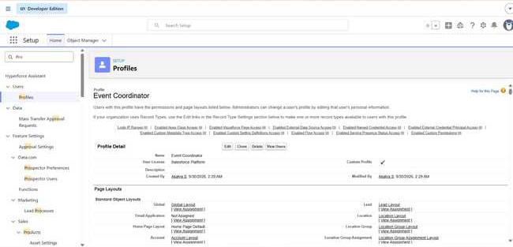

7. Set the Event Planner custom app as the default application.
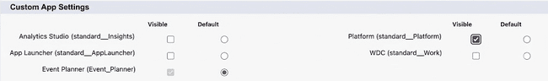

8. Custom Object Permissions

Configure access as follows:

Object | Access
Event | Create, Read, Edit, Delete
Client | Read, Edit
Vendor | Read
Venue | Read
Feedback | Create, Read

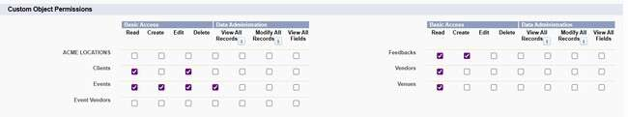
- Set the session timeout to 2 hours of inactivity.
- Configure the password policy.
- Set password expiration to Never Expires.
- Set the minimum password length to 8 characters.
- Save the changes.
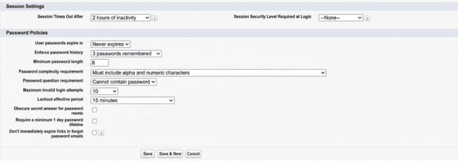
Activity 3:
- Open Setup → Profiles.
- Click New Profile.
- Select Standard Platform User as the base profile.
- Enter Vendor Manager as the Profile Name.
- Click Save.
- Select Edit.
- Set Event Planner as the default custom application.

Object Permissions

Object | Access
Vendor | Create, Read, Edit, Delete
Event | Read
Venue | Read
Client | Read
Feedback | Read

9. Set the session timeout to 2 hours of inactivity.
10. Configure the password settings.
11. Set password expiration to Never Expires.
12. Set minimum password length to 8 characters.
13. Save the configuration.

Activity 4:
- Navigate to Setup → Profiles.
- Select New Profile.
- Choose Standard Platform User as the base profile.
- Enter Client Profile as the Profile Name.
- Click Save.
- Select Edit.
- Make Event Planner the default application.

Object Permissions
Object | Access
Event | Read – Own Events
Feedback | Create, Read
Vendor | No Access
Venue | No Access
- Set the session timeout to 2 hours of inactivity.
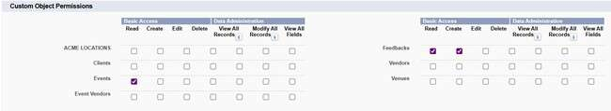
- Configure the password settings.
- Set password expiration to Never Expires.
- Set minimum password length to 8 characters.
- Save the changes.

Milestone 15 - Role:
Roles in Salesforce help establish the organizational reporting structure and determine how record access can be extended through the role hierarchy. Users positioned higher in the hierarchy may receive access to records owned by users below them, depending on the organization's sharing configuration.
Activity 1: Creation of Event Admin Role
- Open Setup.
- Search for Roles in the Quick Find box.
- Select Roles.
- Choose Set Up Roles.

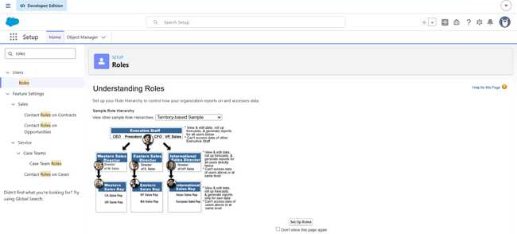
- Click Expand All.
- Under the CEO role, select Add Role.

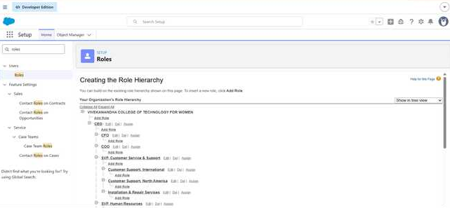
- Enter Event Admin as the Role Label.
- Salesforce automatically generates the Role Name.
- Click Save.
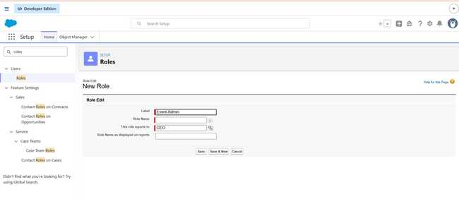
Activity 2: Creating other Role Under Event Admin Role

- Create another role under Event Admin.
- Select Add Role below Event Admin.
- Enter Event Coordinator as the label.
- Allow Salesforce to generate the Role Name.
- Click Save.

Activity 3: Creating other Role Under Event Admin Role

- Add another role beneath Event Admin.
- Enter Vendor Manager as the Role Label.
- The Role Name will be generated automatically.
- Click Save.
Activity 4: Creating other Role Under Event Admin Role

- Create another role under Event Admin.
- Enter Client as the Role Label.
- Allow Salesforce to populate the Role Name.
- Click Save.
The role structure therefore contains:
Event Admin
- Event Coordinator
- Vendor Manager
- Client
Milestone 16 -User:

What is a user?

A Salesforce User is an individual who has an account and can log in to the Salesforce organization. Users may represent employees, administrators, managers, coordinators, or other people who need access to Salesforce records. Their account settings, license, profile, and role determine the features and information available to them.
NOTE :
Salesforce Developer Edition has limitations on the number of users that can use certain licenses. If a required Salesforce license is unavailable, an existing user may need to be deactivated or assigned a different license where appropriate.

Activity 1: To Create a User :
- Open Setup.
- Search for Users in Quick Find.
- Select Users.
- Click New User.
- Enter the required information:
Field | Value
First Name | Sizzler
Last Name | Jaligam
Alias | Suitable Alias
Email | Personal Email
Username | Unique username in text@text.text format
Nickname | Suitable Nickname
Role | Event Admin
User License | Salesforce
Profile | Event Admin
- Click Save.
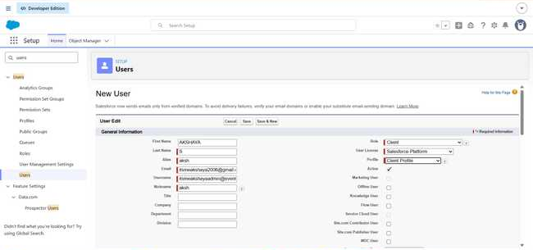
Activity 2: Creating Other Users
Repeat the same process to create users for:
- Event Coordinator
- Vendor Manager
- Client
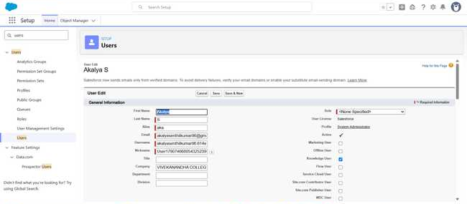
Use the corresponding roles and profiles.
The required license can be assigned according to the available Salesforce licenses in the organization.

Milestone 17 : Permission Set
A Permission Set is a group of additional permissions that can be assigned to users without modifying their existing profile. It allows administrators to provide extra access to specific features or objects when required.
Activity 1: Creating New Permission Set

- Open Setup.
- Search for Permission Sets.
- Select Permission Sets.
- Click New.
- Enter Feedback Manager as the Label.
6. Click Save. 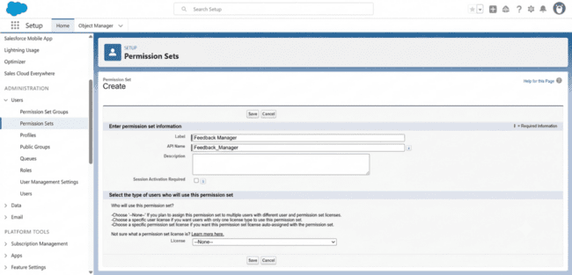

Configure Permissions
- Open the newly created Feedback Manager permission set.
- Navigate to Object Settings.
- Search for the Feedback object.
- Click Edit.
- Under Object Permissions, enable:
  - Read
  - Edit
  - Create
  - Delete
- Click Save.

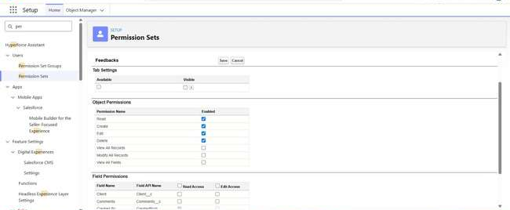

7. Select Manage Assignments.

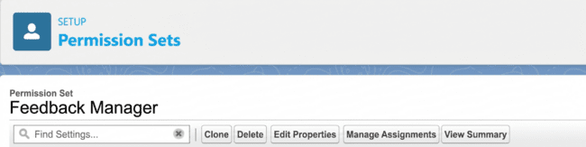

8. Click Add Assignment.

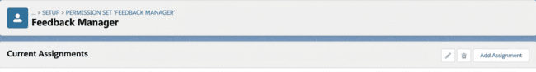

9. Select the appropriate Event Coordinator user.
10. Click Next.
11. Click Assign.
The selected user now receives the additional Feedback permissions.

Milestone 18 : Sharing Settings
Salesforce Sharing Settings determine how records are made available to users within an organization. They are important for protecting sensitive information and ensuring that users receive only the access required for their responsibilities.
Salesforce provides several mechanisms for controlling record access, including:
- Organization-Wide Defaults
- Role Hierarchy
- Sharing Rules
- Manual Sharing
- Apex Sharing

Organization-Wide Default (OWD) Settings:

What is OWD?
Organization-Wide Defaults establish the basic record-level access available to users across the Salesforce organization.
They define the starting access level for records. Additional mechanisms such as Role Hierarchy and Sharing Rules can then be used to extend access when necessary.

OWD Options

1. Private
Only the record owner and users who receive access through the role hierarchy or other sharing mechanisms can access the record.

2. Public Read Only
All users can view the records, while editing is restricted to owners and users with appropriate access.
3. Public Read/Write
Users can both view and modify records, subject to other Salesforce security controls.

4. Controlled by Parent
The access to a child record is determined by the sharing access of its related parent record.
Correct OWD configuration helps administrators protect organizational data while still allowing appropriate collaboration.

Activity 1: Configure OWD
- Open Setup.
- Search for Sharing Settings.
- Open Sharing Settings.
- Click Edit.

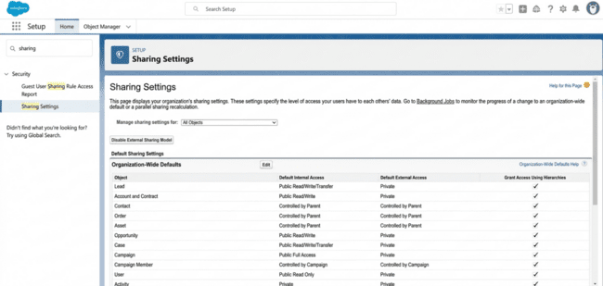

- Locate the Event object under Organization-Wide Defaults.
- Change Default Internal Access to Private.
- Change Default External Access to Private.
- Click Save.
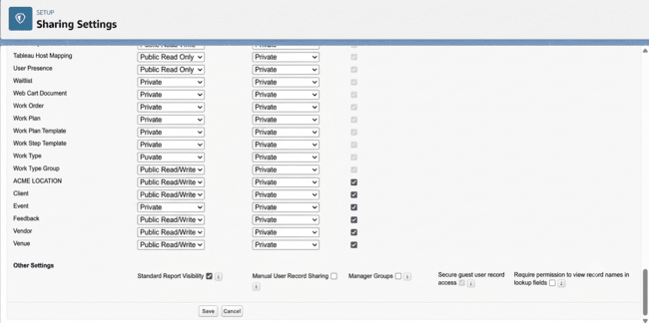

Sharing Rules:

What are Sharing Rules?
Sharing Rules are used to provide additional record access to selected users or groups based on ownership or specific criteria. They are generally useful when the OWD setting is Private or Public Read Only, because sharing rules can extend access but cannot be used to reduce the access already provided by OWD.

Main Types of Sharing Rules
- Owner-Based Sharing Rules
- Criteria-Based Sharing Rules
Activity 1:
Create a sharing rule:
- Open Setup.
- Search for Sharing Settings.
- Locate the Event object.
- Under Sharing Rules, click New. 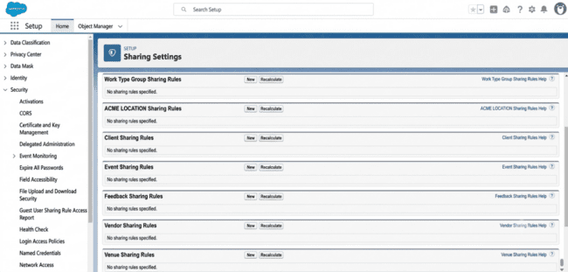

- Enter the label: Event_Sharing_For_Vendors
- Salesforce automatically creates the Rule Name.
- Under the records to be shared, select:
  - Roles
  - Event Coordinator
- Under Share With, select:
  - Roles
  - Vendor Manager
- Set the access level to Read Only.
- Click Save.
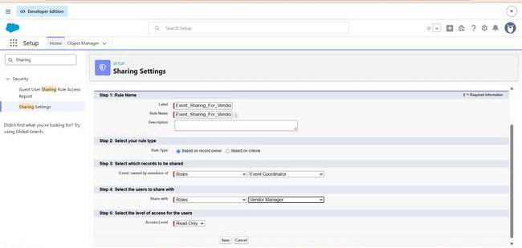

7. FUNCTIONAL & PERFORMANCE TESTING

Testing was carried out to confirm that the major EventForce features operated correctly. Salesforce screens and test results were used to verify important functions such as record creation, client and vendor assignments, validation rules, event status updates, batch processing, scheduled reminders, and dashboard reporting. The testing process checked whether automation worked as expected, whether records were processed correctly, and whether users received the appropriate level of access.
8. ADVANTAGES & DISADVANTAGES
Advantages
- Centralized Information
Event, Client, Vendor, Venue, Feedback, and EventVendor information is maintained within one Salesforce platform.
- Automated Processes
Salesforce Flows automate reminders and other repetitive operations, reducing the need for manual work.
- Double-Booking Prevention
Apex Triggers and the VenueStatusHelper class help identify venue conflicts and maintain venue availability.
- Structured Cancellation Handling
The Approval Process provides a defined procedure for submitting and processing event cancellation requests.
- Better Operational Monitoring
Reports and Dashboards make event schedules, vendor activities, and feedback information easier to monitor.
- Controlled Data Access
Profiles, Roles, Permission Sets, OWD, and Sharing Rules help regulate access to Salesforce records.
- Future Scalability
The Salesforce platform can be extended as the number of events, users, and business requirements increases.
- Improved Data Accuracy
Validation Rules and data checks performed before migration help maintain consistent and reliable information.

Disadvantages
- Developer Edition Constraints
The application was developed using Salesforce Developer Edition for academic purposes and was not connected to a live production environment.
- No Production Deployment
Moving the completed solution into a production Salesforce organization was outside the scope of this project.
- Additional Deployment Requirements
Real-world deployment may require tools and environments such as Sandboxes, Change Sets, Salesforce DX, or DevOps and CI/CD solutions.
- Technical Configuration Complexity
Managing Apex, Flows, Approval Processes, and Salesforce security settings requires suitable technical knowledge.
- Continuous Maintenance
Automation, Apex jobs, approval processes, validation rules, and sharing configurations require periodic monitoring and maintenance.

9. Conclusion:
The EventForce Management System demonstrates the use of Salesforce to organize, automate, and simplify event-management activities. The solution brings Events, Clients, Vendors, Venues, Feedback, and EventVendor information into a centralized Salesforce environment. The project combines Lightning Apps, Flows, Validation Rules, Formula Fields, Approval Processes, Apex Triggers, Apex Classes, Batch Apex, Scheduled Apex, security controls, Reports, and Dashboards to satisfy major event-management requirements. Automation supports important activities such as event reminders, cancellation approvals, venue availability updates, prevention of duplicate bookings, and automatic completion of past events. The implementation also highlights the importance of data migration, testing, security, documentation, and maintenance in Salesforce-based solutions. Although the system was developed and tested in a Developer Edition organization and was not deployed to production, it demonstrates practical Salesforce implementation concepts and provides a foundation for future improvements and expansion.
10. FUTURE SCOPE
The EventForce Management System can be expanded with additional capabilities to support larger event operations and provide improved automation and integration.
- Production Deployment
The solution can be moved from the development environment to a production Salesforce organization using suitable deployment methods.
- Advanced Event Automation
Additional automated processes can be introduced to simplify more event-planning and operational tasks.
- Enhanced Vendor Management
Vendor tracking can be expanded with additional features for evaluating services, performance, and vendor activities.
- Advanced Analytics
More reports and dashboards can be created to provide deeper insights into events, venues, vendors, budgets, and client feedback.
- External Integrations
The application can be connected with external applications and services required for real-world event operations.
- Mobile Accessibility
The system can be optimized for easier access and event management through mobile devices.
- Scalability Improvements
The application can be extended to handle larger numbers of events, clients, vendors, venues, and users.
- Continuous Maintenance and Optimization
Flows, Apex code, validation rules, sharing configurations, and other Salesforce components can be regularly reviewed and improved as requirements change.
These enhancements can gradually develop the current EventForce solution into a more comprehensive and enterprise-oriented event management CRM platform.

11. APPENDIX
A. Custom Objects
- Event
- Client
- Vendor
- Venue
- EventVendor
- Feedback
B. Automation
- Flows
- Validation Rules
- Approval Process
- Apex Triggers
- Apex Classes
C. Processing
- Batch Apex
- Scheduled Apex
- D. Security
- Profiles
- Roles
- Permission Sets
- Organization-Wide Defaults
- Sharing Rules
E. Data Migration
- Salesforce Data Import Wizard
F. UI & Analytics
- Lightning App
- Reports
- Dashboards
G. Testing & Documentation
- Configuration Testing
- Security Testing
- Automation Testing
- Project Documentation

Thank You

